**Write a Java program to Check if a binary tree is binary search tree or not**

class Node

{

int data;

Node left, right;

public Node(int item)

{

data = item;

left = right = null;

}

}

public class BinaryTree

{

Node root;

boolean isBST() {

return isBSTUtil(root, Integer.MIN_VALUE,

Integer.MAX_VALUE);

}

boolean isBSTUtil(Node node, int min, int max)

{

if (node == null)

return true;

if (node.data < min || node.data > max)

return false;

return (isBSTUtil(node.left, min, node.data-1) &&

isBSTUtil(node.right, node.data+1, max));

}

public static void main(String args[])

{

BinaryTree tree = new BinaryTree();

tree.root = new Node(7);

tree.root.left = new Node(2);

tree.root.right = new Node(5);

tree.root.left.left = new Node(1);

tree.root.left.right = new Node(3);

if (tree.isBST())

System.out.println("IS BST");

else

System.out.println("Not a BST");

}

}

**Node= 4,2,5,1,3 IS BST**

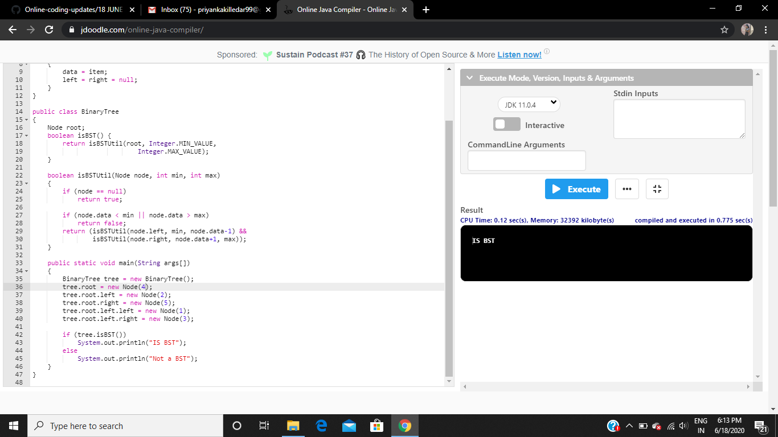

**Node= 7,2,5,1,3 IS NOT BST**